LoginScenario_TestForMarineValidLogin_Instance1_04-Jul-2017_02-56-52_AM_Enter_user_credentials.png

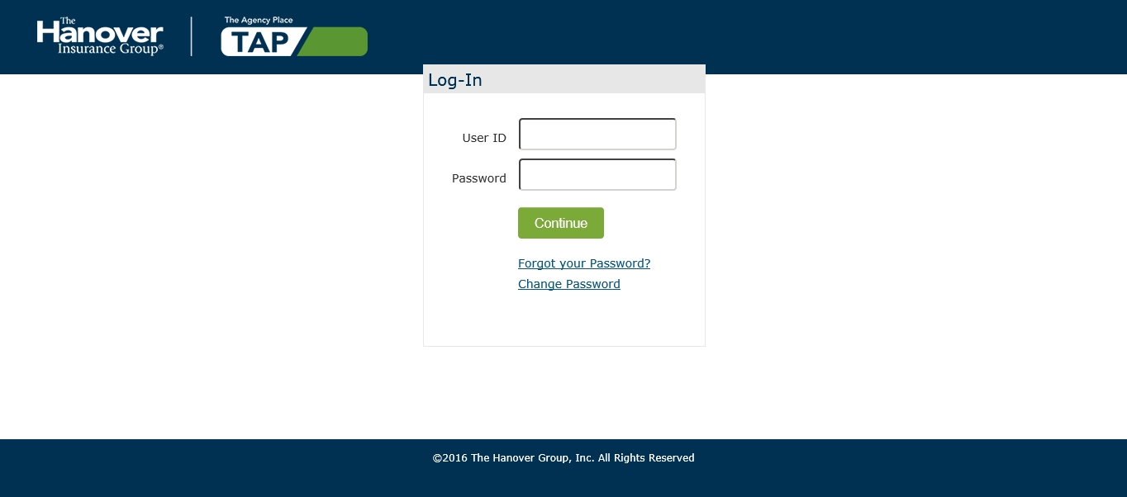

LoginScenario_TestForMarineValidLogin_Instance1_04-Jul-2017_02-56-53_AM_Login.png

